SQL_Assignments_Set5
All the questions are based on India and Australia tables
In the TrID column the first 3 characters are country code followed by _, then the next 3 digits are for the transaction serial number followed by _ and finally last two characters are for counter number, i.e. through which counter the transaction has happened.
- Display all columns along with new column Discounted_Amount as 5% on the amount for those transactions having quantity sold is above 3 for both the countries.
select * , amount*.05 'Discounted Amount'
from India
where Qty>3
union
select * , amount*.05 'Discounted Amount'
from Australia
where Qty>3

- Display product name wise number of products sold in each country along with a sub total of each country as shown next:

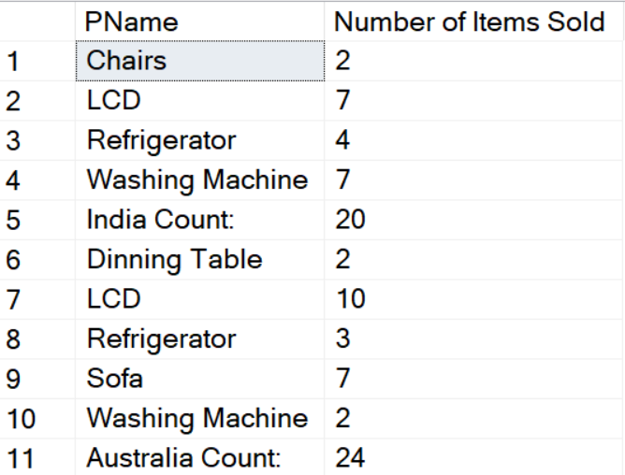
SELECT Pname, COUNT(Qty) AS 'Number' FROM India
group by Pname
union
select 'India Count: ',count(qty) from India
union
SELECT Pname, COUNT(Qty) AS 'Number' FROM Australia
group by Pname
union
select 'Australia Count: ', count(qty) from Australia
- Display the following output:
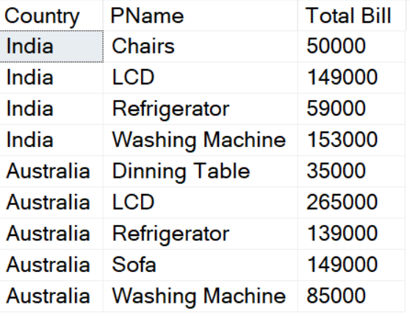
The Total bill will be summation of amounts as per products within each country.
SELECT 'India' as 'Country', Pname, sum(amount) AS 'Total Bill' FROM India
group by Pname
union
SELECT 'Australia' as 'Country', Pname, sum(amount) AS 'Total Bill' FROM Australia
group by Pname
- Display week days transaction details for both the countries excluding the transactions done on 1-Jan-2019.
select * from India
where DOP != '1-Jan-2019'
union
select * from Australia
where DOP != '1-Jan-2019'
- Display all the transactions of India as well as Australia sorted as per date of purchase oldest to latest. Also display grand total of amounts country wise as the last 2 rows in the output.
select * from India
union
select * from Australia
union
select 'India',Null,Null,Null, sum(amount) from India
union
select 'Australia',Null,Null,Null, sum(amount) from Australia
order by DOP desc

- Display all the transaction details done in counter 3 for both the countries.
select * from India
where TrID like '%3'
union
select * from Australia
where TrID like '%3'

